FIN.SOP.X.008
Cash Advances in Emergencies
FNM Standard Operating Procedure
Target Audience: All Staff

POLICIES AND PROCEDURES

DISCLAIMER

Standard Operating Procedures (SOPs) provide a step-by-step guide for staff directly involved in the processing of administrative actions to support and facilitate the implementation of WHO policies and procedures. The SOPs are for guidance only; they are neither authoritative nor binding. The SOPs reflect the policies and procedures of WHO at the time of writing; however, policies and procedures change from time-to-time. In the case of a conflict between the SOPs and the WHO eManual provisions, the WHO eManual provisions take precedence.

DOCUMENT SPECIFICATIONS

Version Version | Date of revision | Author (s) / Dept / Unit | Approver | Indicate which section (s) changed compared to previous version
1.0 | November 2015 | BARNABE, Carmelle | BERG, Valpuri; STEWART PAPPAS, Jane Margaret; JEFFREYS, Nicholas Richard | Original version
1.1 | July 2023 | DEE, Angelita | STEWART, Francis | Item 2.4 – Cash-in-transit Insurance
1.2 | November 2023 | BOR, Florence | KYRIAKOU, George | Update to align with FIN.SOP.X.007 Imprest Purchase. Update of the process steps to report incidents

Introduction

This SOP related to cash advances is to be followed under graded emergencies (please refer to the list of graded emergencies)

In exceptional circumstances, WHO staff, consultants and SSA Holders may require cash to assist in the set up and maintenance of emergency response operations in the field when regular payment mechanisms are not available or where the local infrastructure has been severely damaged. Due to the security and financial risks of carrying cash, the office must always seek alternative options first that are available within the local environment to meet the requirements. Where carrying cash is the only feasible option, the WHO staff, consultant and/or SSA holder may be granted an emergency cash advance to assist in undertaking necessary activities. Whenever it is possible to make bank transfers, cash advances should not be used.

Regional Budget and Finance Officers and the regional Director of Administration and Finance should be consulted if cash advances are required to be paid to recipients other than those listed above (WHO staff, consultants and SSA Holders) due to security constraints.

Emergency cash advances should not be confused with travel per diem payments or Operational advances under Direct Implementation . Travel per diem is for travellers' living expenses (accommodation, meals, etc.). Operational advances under Direct Implementation are made for programme implementation activities in the field, such as disbursements to end-beneficiaries including vaccinators and participants and are recorded against specific DI IPOs. Refer to FIN.SOP.XVI.002 Direct Implementation for additional details.

This SOP does not apply to Cash Advances in Emergencies released in HQ for which specific process steps should be followed. Please contact the Treasury.

General Guidance / Business Rules

Emergency cash advances may cover payments to be made in the field for critical expenses (such as emergency supplies when arriving in devastated areas, fuel, car rentals, communications, establishment of field offices, hiring of temporary personnel such as labourers, and other local costs directly related to WHO’s emergency response operations) when regular payment mechanisms such as bank transfers are not available.

The need for a cash advance is identified by the Responsible Technical Officer together with the custodian of the operational advance. Once a need is identified, the Responsible Technical Officer obtains approval from the Head of Country Office(HCO)/WHO Representative(WR) that an emergency cash advance may be paid. The HCO/WR’s approval should be documented and attached to the Imprest Voucher. Refer to section 3.3 for a sample Cash Needs Assessment Template (to help determine the amount required as an advance). The OO/AO or the Security officer (depending on the context) is responsible for making appropriate security arrangements to protect the cash advance custodian and WHO’s cash asset. These arrangements must be commensurate with the level of risk of the situation.

Emergency cash advances may also be provided by Treasury at HQ to eligible staff members traveling for emergency missions on short notice or to guarantee cash availability for the first few days of an emergency deployment. Howver, where possible, cash advances should be provided to eligible persons at the country level in order to avoid the unnecessary carrying of large sums of money through international borders and thereby also avoid potential violation of the respective country legislations .

Individuals receiving emergency cash advances should not carry cash advances for other people, lend money from their cash advance to other people (including other WHO or UN staff) or mix the cash advance with other money (such as their travel per diem advances).

Imprest Cash Account

The WHO country office (WCO) provides the necessary cash advance within 24 hours of receiving a written request (subject to cash availability) for emergency procurement at the local level through the WCO’s Imprest cash account.

Thresholds

The limits on operational cash advances per person at a time that can be approved in emergencies by the HCO/WR are:
- US$20,000 for staff
- US$10,000 for consultants and SSA Holders

Any requests for amounts higher than the above thresholds should be forwarded to the Regional Budget and Finance Officer for approval.

Cash Advance Payments

Advances provided at the local level are paid in the local currency through the WCO’s Imprest cash account.

When the expenses to be incurred are clearly defined before granting the cash advance and the related expenditure type(s) can be determined, an IPO should be raised and the payment category “Operational Advance" should be selected at the creation of the voucher. Please refer to FIN.SOP.X.007 Imprest Purchase Order (Operational advances in graded emergencies).

If the related expenditure type(s) cannot be determined when the advance is granted , emergency cash advances will be paid via Imprest and are recorded under the “ACT/BFO Authorised Transactions” transaction type in the miscellaneous module. This action charges GL 145024 which is the eImprest Miscellaneous Transactions Clearing Account. The Imprest focal point/finance assistant prepares the Imprest Voucher, obtains the appropriate authorizing signature, and provides the funds to the recipient, who then signs the Imprest Voucher as evidence that he or she received the funds. The narrative “Emergency Cash Advance to (RECIPIENT NAME)” should be indicated in the Imprest Voucher description.

Emergency cash advances must be recorded and monitored in the Operational Advances SharePoint.

Cash advance recipients are required to certify the “Cash Advance Acknowledgement Form” before receiving cash. Refer to Section 3.3.

The recipient is required to submit a completed Cash Advance Disbursement Form (refer to section 3.3 for an example disbursement form) within 30 days of returning from the mission for which funds were required or before their contract end date, whichever comes first. Any requests for extensions to the 30 day requirement must be approved by the Regional Budget and Finance Officer. Invoices and supporting documentation for each disbursement and receipts for exchange rate transactions must be attached to the form. If the recipient fails to account for all or part of the cash advance, or amounts disbursed are not supported or are unjustified, the recipient is required to refund the balance to WHO. If the recipient fails to return the funds, the amounts owing will be recovered from future payments or remuneration entitlements.

It is the responsibility of the recipient to ensure that cash received is safeguarded, that regular cash counts are performed, supporting documentation and/or invoices are retained for each transaction, completed Cash Advance Disbursement Forms are provided to the WCO on a timely basis, and that any unspent balance is returned to the WCO upon completion of the mission/activity.

The Imprest focal point/finance assistant reviews the recipient’s Cash Advance Disbursement Form. This review includes verifying that expenditures are supported by invoices, that disbursements are justified (e.g. no personal expenses were submitted, disbursements are in accordance with the purpose of the advance, etc.), and that the submission is mathematically accurate.

Once the completed Cash Advance Disbursement Form has been verified and any outstanding amounts returned to the WCO, the Imprest focal point/finance assistant records the receipt of amounts returned (if any), records the expenditures incurred to an Imprest PO and clears the advance from GL 145024. When recording expenditures to an Imprest PO, a Imprest voucher is created against an Imprest PO which contains an expenditure type that is line with the nature of the disbursement made. Expenditures may therefore be allocated to multiple Imprest POs to align the expenditure with the correct expenditure type and/or to charge the correct PTA combination. However, no payment is made upon issuing this Imprest Voucher as funds were disbursed when paying the advance. Thereafter, the Imprest focal point/finance assistant clears the advance from the temporary account by recording the following journal entry:
Dr. Imprest Account
Cr. eImprest Miscellaneous Transactions Clearing Account 145024

Cash-In-Transit Insurance

WHO is now self-insured for cash-in-transit and cash in Country Office safes. FNM/IRM manages a self insured fund which will absorb any cash losses exceeding USD 100,000 up to a maximum of USD 1,000,000 per event. This means that operating units must absorb any losses up to USD 100,000 (and above USD 1,000,000). There is no longer any need to pre-advise TSY of the transport of cash.

For questions, please contact IRM at insurance@who.int

Security Measures, Theft and Robbery

Persons receiving emergency cash advances should take the following precautions to ensure the safeguarding of cash.
- Always limit the amount of cash carried on your person.
- On arrival at the duty station, cash should be kept in a safe at the hotel or in the local WHO office.
- Limit the awareness of others of the presence of cash.
- If the cash is being used to open a field office, a reliable safe should be installed as soon as possible and be cemented into an inside wall of the office. Further dual access facilities should be put in place:
  - A combination (known by person A) and key (held by person B)
  - A set of two keys (one for person A and one for person B).
- Ensure the cash advance balance is reconciled at the end of each working day.

Individuals confronted with armed robbers should surrender the money without resistance. Under no circumstances should the individual endanger his life in order to protect any goods or property, including money.

Any loss of cash should be reported to the police within 24 hours of its discovery, and a police report must be requested and forwarded as soon as possible to the Regional Budget and Finance Officer and to the Treasury at the HQ. To report a security incident, the custodian fills in the Security and Safety Incident Reporting (SSIR) Template and transmits the same at the earliest to the nearest UNDSS or WHO Security Office.

Verification Activities

The OO/AO is responsible for overseeing/monitoring the status of the cash advances by regularly reviewing their status in the cash advance tracking log and/or in the Operational advance SharePoint and ensuring that they are justified and closed in a timely manner.

On a monthly basis, the Regional Budget and Finance Officer reviews the list of ACT/BFO Authorised Transactions and the eImprest Miscellaneous Transactions Clearing Account and coordinates with the WCO accordingly to ensure advances are being cleared and settled on a timely basis.

Reference Material

    - WHO eManual

X.3 Imprest
XVI.5 Direct Implementation
VII.5 Travel Per Diem and Other Allowances

    - Related SOPs

FIN.SOP.X.007 Imprest Purchase Orders
FIN.SOP.XVI.002 Direct Implementation
FIN.SOP.X.73 Cash Insurance

    - Other

Cash Advance Disbursement Form | Cash Advance Tracking Log | Cash Needs Asssement Template | Cash Advance Acknowledgement Form

5. PROCESS FLOW*

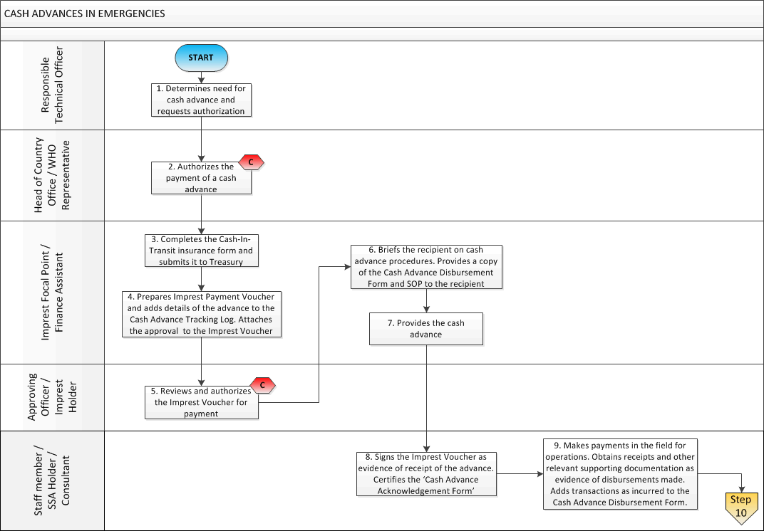

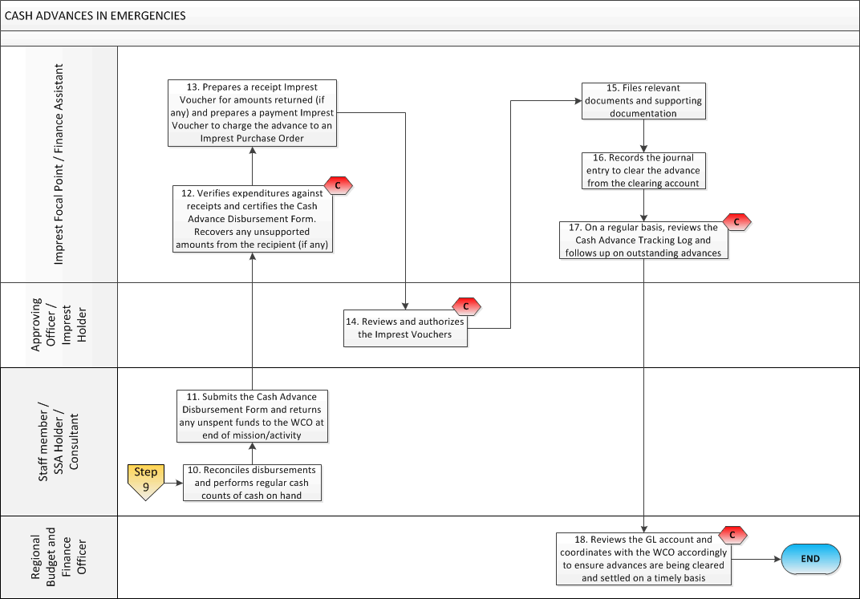
6. PROCESS STEPS

Step | Control (C) | Type | Description | Role / Responsibility
1 |  | Offline | Determines need for cash advance and requests authorization. | Responsible Technical Officer
2 | C | Offline | Authorizes the payment of a cash advance. | Head of Country Office/WHO Representative
3 |  | GSM | Prepares the Imprest Payment Voucher and adds the details of the advance to the Cash Advance Tracking Log and the operational advance sharePoint. Attachs the approval from the Head of Country Office/WHO Representative to the Imprest Voucher. | Imprest Focal Point/Finance Assistant
5 | C | Offline | Reviews and authorizes the Imprest Voucher for payment. | Approving Officer/Imprest Holder
6 |  | Offline | Briefs the recipient on cash advance procedures. Provides a copy of the Cash Advance Disbursement Form and SOP to the recipient. | Imprest Focal Point/Finance Assistant
7 |  | Offline | Provides the cash advance. | Imprest Focal Point/Finance Assistant
8 |  | Offline | Signs the Imprest Voucher as evidence of receipt of the advance. | Staff member / SSA Holder/ Consultant
9 | C | Offline | Makes payments in the field for operations. Obtains receipts and other relevant supporting documentation as evidence of disbursements made.  Adds transactions as incurred to the Cash Advance Disbursement Form. | Staff member / SSA Holder/ Consultant
10 |  | Offline | Reconciles disbursements and performs regular cash counts of cash on hand. | Staff member / SSA Holder/ Consultant
11 |  | Offline | Submits the Cash Advance Disbursement Form and returns any unspent funds to the WCO at end of mission/activity. | Staff member / SSA Holder/ Consultant
12 | C | Offline | Verifies expenditures against receipts and certifies the Cash Advance Disbursement Form. Recovers any unsupported amounts from the recipient (if any). Update the Cash Advance Tracking Log and the operational advance sharePoint | Imprest Focal Point/Finance Assistant
13 |  | GSM | Prepares a receipt Imprest Voucher for amounts returned (if any) and prepares a payment Imprest Voucher to charge the advance to an Imprest Purchase Order. | Imprest Focal Point/Finance Assistant
14 | C | GSM | Reviews and authorizes the Imprest Vouchers. | Approving Officer/Imprest Holder
15 |  | ECM | Files relevant documents and supporting documentation. | Imprest Focal Point/Finance Assistant
16 |  | GSM | Records the journal entry to clear the advance from the clearing account. | Imprest Focal Point/Finance Assistant
17 | C | Offline | On a regular basis, reviews the Cash Advance Tracking Log and the operational advance sharePoint and follows up on outstanding advances. | Imprest Focal Point/Finance Assistant
18 | C | GSM | Reviews the GL account and coordinates with the WCO accordingly to ensure advances are being cleared and settled on a timely basis. | Regional Budget and Finance Officer

7. KEY RISKS & COMPENSATING CONTROLS
Risks | Compensating Controls | Process Step
Advances are not authorized. | Head of Country Office/WHO Representative Authorizes the cash advance.  Approving Officer/Imprest Holder reviews and authorizes the Imprest Voucher for payment. | 2,5
Disbursements are undocumented, unsupported, or unjustified. | Staff member / SSA Holder obtains receipts and other relevant supporting documentation as evidence of disbursements made.  Imprest Focal Point/Finance Assistant verifies expenditures against receipts and certifies the Cash Advance Disbursement Form. | 9, 12
Advances are not settled/unspent funds are not returned. | Imprest Focal Point/Finance Assistant verifies expenditures against receipts and certifies the Cash Advance Disbursement Form.  Approving Officer/Imprest Holder reviews and authorizes the Imprest Voucher for payment.  Imprest Focal Point/Finance Assistant reviews the Cash Advance Tracking Log and follows up on outstanding advances.  Regional Budget and Finance Officer reviews the GL account and coordinates with the WCO accordingly to ensure advances are being cleared and settled on a timely basis. | 12, 14, 17, 18

WCOs (to the extent possible) estimate the expected cash needs of the office when an emergency is identified to ensure that adequate levels of funds are available in both the Imprest bank and cash account. WCOs should contact the Regional Budget and Finance Officer and Treasury as soon as possible if funding needs exceed regular replenishment levels and cash shortages are identified. In these cases, an ad-hoc replenishment may be processed. In emergencies, exceptions to Imprest ceiling limits may be approved by the Regional Budget and Finance Officer.

